Case 2-Afr-Egy-Ushabti-Hieroglyphics-Two Ankh-One Scarab-664-332 BCE

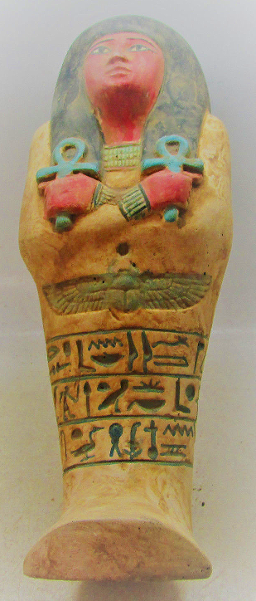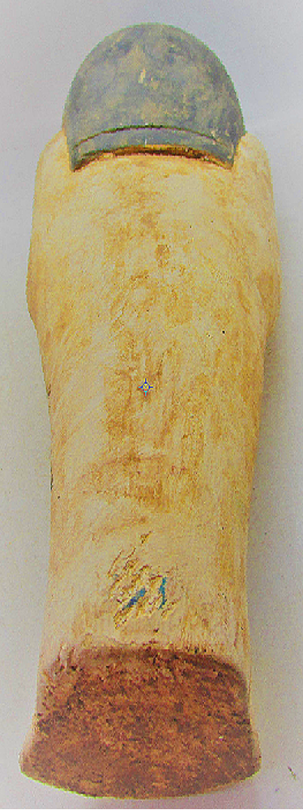
Case no.: 2
Accession Number:
Formal Label:
Display Description:
LC Classification:
Date or Time Horizon: 664-332 BCE
Geographical Area:
Map:
GPS coordinates:
Cultural Affiliation:
Media:
Dimensions:
Weight:
Condition:
Provenance:
Discussion:
References:

